**Project Documentation**

Project Title – Electronics Rental System

On fulfillment of Digital Internship in **Exavalu** by- **Group D**

|  |  |
| --- | --- |
| Team Member - | **Ankita Saha** |
|  | **Arka Bhattacharya** |
|  | **Deep Dubey** |
|  | **Indrajit Chatterjee** |
|  | **Sourav Bhunia** |
|  | **Subhankar Maity** |
|  |  |

## Introduction

Basic computer skills and practice of theoretical skills on Personal computer has become a new need for almost every student and employees regardless of their relevance with IT industry. From the reports released from the government of India, the average salary of a person ranges from 8080-143,000 INR implying that buying a good laptop is still dream to many people in countries like India. Such people approach net centers for system use but people living in rural areas face the crisis since not many net centers could be present in those areas. Mostly people lend laptops from their acquaintances and use them but not every person have such acquaintances. In such cases laptop renting can solve the problem. Not every person needs the same configured laptop and not every person needs the same software in a laptop, so, net centers cannot gear up to the customer needs. The present system of rental provides a person with a laptop chosen with basic software but now the expectations have crossed that bar. People find it useful to rent a laptop on demand and with pre-installed required software without having to waste their time. The problem is that there is no such platform to cater to the needs of the demand. Considering all problems together and putting the solutions to them in one platform gives our android app “Electronic Rental System” App. Through his application user can select the laptop of his desired configuration and choose one with his required pre-installed software to be delivered at his place and date of his convenience.

## Objective

This study's main objective is to focus on solving societal problems. The objective of this initiative is:

* To understand the problems and struggles faced by the rural people and poor literates in obtaining computer services.
* To establish a system of laptop rental services available to each and every person.
* To find a simple way in providing an efficient method of renting laptops, desktops or tablets.

## Benefits of Electronics Rental System

We developed this project to book laptops, desktops and tablets for rent at the fare charges. In the present system all booking work done manually and it takes very hard work to maintain the information of booking and the devices. If you want to find which device is available for booking then it takes a lot of time. It only makes the process more difficult and harder. This aim of the project is to automate the work performed in the laptop, desktop and tablet rental management system like generating daily bookings, records of devices or device available for booking, rental charges for devices, store record of the customer.

Electronic rental management system is a laptop, desktop and tablet booking software that provides a complete solution to all your day-to-day device booking office running needs. This system helps you to keep the information of Customer online. You can check your customer information any time by using this system. Electronic rental management system is a unique and innovative product. Using this you can also keep the information on the number of bookings in the current month or in the last 6 months or in last year. This helps you to track your business and your earnings in a particular month or in any year. Based on this information you can take a decision regarding your business development.

## Features

Our Electronic Rental System application has the following key features:

* When the user opens the app, the application prompts the user to login or register.
* First user has to register giving his mail id and setting a password.
* If the user wants to rent a laptop he can go to the catalog and search for his desired laptop, desktop or tablet and look up its features and availability.
* If it is available, the user next books the laptop for a date and specifies the time and waits for approval.

# THEORETICAL BACKGROUND

**The Project is comprised of the following: -**

1. **HTML: -**The **Hypertext Markup Language**, or **HTML** is the standard markup language for documents designed to be displayed in a web browser. It can be assisted by technologies such as Cascading Style Sheets (CSS) and scripting languages such as JavaScript.
2. **CSS: -Cascading Style Sheets** (**CSS**) is a style sheet language used for describing the presentation of a document written in a markup language such as HTML.[[1]](https://en.wikipedia.org/wiki/CSS#cite_note-1) CSS is a cornerstone technology of the World Wide Web, alongside HTML and JavaScript.
3. **JSP: -**JSP technology is used to create web applications just like Servlet technology. It can be

thought of as an extension to Servlet because it provides more functionality than servlet such as expression language, JSTL, etc.

1. **JS: -JavaScript** is a programming language that is one of the core technologies of the World Wide Web, alongside HTML and CSS. Over 97% of websites use JavaScript on the client side for web page behavior, often incorporating third-party libraries. All major web browsers have a dedicated JavaScript engine to execute the code on users' devices.
2. **jQuery: -**jQuery is a fast, small, and feature-rich JavaScript library. It makes things like HTML document traversal and manipulation, event handling, animation, and Ajax much simpler with an easy-to-use API that works across a multitude of browsers. With a combination of versatility and extensibility, jQuery has changed the way that millions of people write JavaScript.
3. **AJAX: -**is a set of web development techniques that uses various web technologies on the client-side to create asynchronous web applications. With Ajax, web applications can send and retrieve data from a server asynchronously (in the background) without interfering with the display and behavior of the existing page. By decoupling the data interchange layer from the presentation layer, Ajax allows web pages and, by extension, web applications, to change content dynamically without the need to reload the entire page.[[3]](https://en.wikipedia.org/wiki/Ajax_(programming)#cite_note-wrox-3) In practice, modern implementations commonly utilize [JSON](https://en.wikipedia.org/wiki/JSON) instead of XML.
4. **JAVA: -**Java is a programming language and a platform. Java is a high level, robust, object-oriented and secure programming language.

Java was developed by *Sun Microsystems* (which is now the subsidiary of Oracle) in the year 1995. *James Gosling* is known as the father of Java. Before Java, its name was *Oak*. Since Oak was already a registered company, so James Gosling and his team changed the name from Oak to Java.

1. **Module Uses: -**
   1. STRUTS2
   2. Bootstrap, HTML, CSS, Java Script
2. **Database Used: -** MySQL

Software Model

In this project, we are using the Iterative waterfall model as our software model. We are using Iterative waterfall model as it is the extension of Waterfall model. The iterative waterfall model provides feedback path from each phase to its previous phase, which makes the project handling easy. For every new version of the application, we can iterate through the beginning and make changes wherever there is needed. Every release of the Iterative Model finishes in an exact and fixed period that is called iteration.

There are different phases of Iterative model and they are as follows: -

1. **Requirement gathering & analysis:** In this phase, we gathered the requirements according to the project need. After requirement gathering, we move ahead with the next steps
2. **Design:** In the design phase, we design the software by the different diagrams like Data Flow diagram, activity diagram, class diagram, state transition diagram, etc.
3. **Implementation:** In the implementation, we write the requirements in the coding language and transform it into computer programs which are called Software.
4. **Testing:** After completing the coding phase, software testing starts using different test methods. We are using Junit for testing.
5. **Deployment:** After completing all the phases, the software is deployed to its work environment.
6. **Review:** In this phase, after the product deployment, we started the review phase in which we check the behavior and validity of the developed product. And if there are any errors found then the process starts again from the requirement gathering.
7. **Maintenance:** In the maintenance phase, after deployment of the software in the working environment there may be some bugs, some errors or new updates are required.

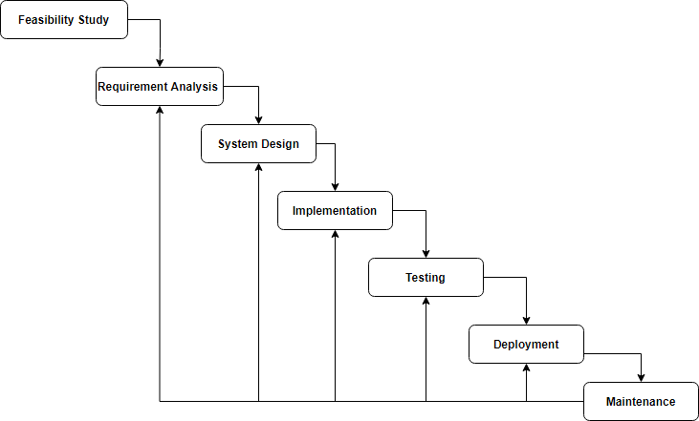

Fig: Iterative Waterfall model diagram

#### Why we are using the Iterative model: -

* + **Feedback Path** – In the classical waterfall model, there are no feedback paths, so there is no mechanism for error correction. But in the iterative waterfall model feedback path from one phase to its preceding phase allows correcting the errors that are committed and these changes are reflected in the later phases.
  + **Simple** –Iterative waterfall model is very simple to understand and use.
  + **Cost-Effective** –It is highly cost-effective to change the plan or requirements in the model.
  + **Well-organized** –In this model, less time is consumed on documenting and the team can spend more time on development and designing.

## Database Structure

We have used 4 database tables for our project namely **role_table, user, products, orders.** The table structure looks like below: -

**Schema Name:** electronic_rental_system

**Table 1: role_table**

|  |  |  |  |
| --- | --- | --- | --- |
| RoleTable | Datatype | Constraint | |
| roleId | int | primary key | Not Null |
| roleName | varchar |  | Not Null |

**Table 2: user**

|  |  |  |  |
| --- | --- | --- | --- |
| Customer/User/Admin | Datatype | Constraint | |
| userID | int | primary key | auto increment |
| userName | varchar |  | Not Null |
| userMobileNo | int(10) | unique | Not Null |
| userEmail | varchar | unique | Not Null |
| password | varchar |  | Not Null |
| city | varchar |  | Not Null |
| country | varchar |  | Not Null |
| status | int(1) |  |  |
| roleId | int(1) | foreign key (roleTable - roleId) | Not Null |

**Table 2: products**

|  |  |  |  |
| --- | --- | --- | --- |
| Products | Datatype | Constraint | |
| productId | int | primary key | auto increment |
| productName | varchar/text |  | Not Null |
| productMake | varchar/text |  | Not Null |
| productPrice | double |  | Not Null |
| availability | int |  | Not Null |
| status | int |  | Not Null |
| productImage | varchar(imageLink) |  |  |

**Table 2: orders**

|  |  |  |  |
| --- | --- | --- | --- |
| Orders | Datatype | Constraint | |
| orderId | int | primary key | auto increment |
| productId | int | foreign key(product table-on delete and update casecad) | Not Null |
| customerId | int | foreign key(customer table- -on delete and update casecad) | Not Null |
| startDate | string/date |  | Not Null |
| endDate | string/date |  | Not Null |
| quantity | int |  | Not Null |

This is the database diagram for the following tables :

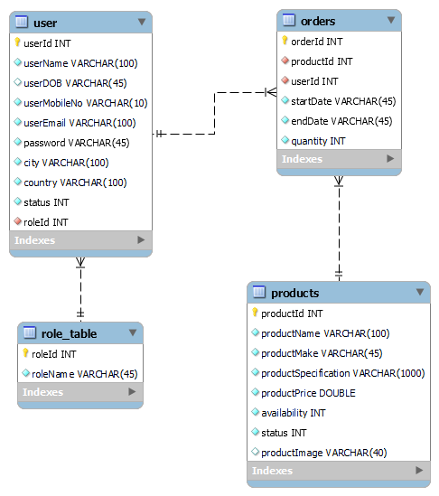

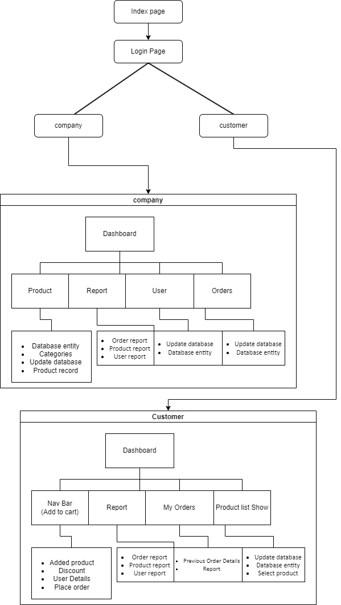Flowchart

## Future Scope

In today’s competitive world, learning skills through a laptop or system has become a basic need for almost every student and employee. But that requirement comes with a cost. A well configured laptop costs a fortune for a middle-class family. Net Centers can provide a solution but the problem comes when a question comes about flexible time and location and the quality of the infrastructure provided, it fails to satisfy these needs that user want. To all these problems, renting a laptop can stand as a solution but an integrated platform needs to be present to get the task done. The basic idea is to create an android application platform to rent and let people lend the laptops on demand online which is available 24/7. The users on entering the app can check the features they want and search for the laptops and their availability. If the laptop is available, he goes ahead and gives his details and address and automatically a rent requested is formatted.

## Conclusion

This study summarizes an efficient way of renting a well configured laptop, desktop or a tablet to users. The app provides users with the chance to lend a laptop, desktop or a tablet at a reasonable price with customized software requirements unlike the traditional system of approaching a net center at inflexible time and limited hardware and software resources.